1. Read the text and answer the questions.

Tom's story
a I lived in a small town in the north of Finland. It was very cold in winter – colder than in London. ….

Where did Tom live?

_____________________________________________________________________________
What was his father's job?

_____________________________________________________________________________

Match the titles to parts a-e of the text.

Write the numbers in the boxes.
Tom's home □

Circle the correct answers.

How many children were there in Tom's family?
a) three b) four c) eight

2. Look at the pictures. Write the names of the animals.

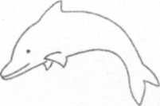

_______________

Circle the odd one out.

red hall blue pink green

3. Circle the correct word.
What's you/your name?

4. Write questions.

Snowy likes bread.
Does Snowy like bread?
5. Describe the picture. (Write five sentences)

__________________________________________________________
__________________________________________________________
__________________________________________________________
__________________________________________________________
__________________________________________________________
__________________________________________________________

