1. Read the text and answer these questions.

Rob's grandmother, Marta Vialli
a I was born in a small village in the mountains in the north of Italy. It was very cold in winter – colder than London. But the summers were nice.
b I am from a large family - I had three brothers and four sisters. I was older than my sisters but two of my brothers were older than me.
с We lived in a big house. It had blue windows and red doors. I had a bedroom with two of my sisters at the top of the house. When you stood at the window you looked down on the garden. I think it was nicer than the other gardens in the village.
d My father was a baker and my mother worked in the shop. They got up at three o'clock every day to make cakes and bread. In the holidays I helped in the shop.
e I went back to my village last year for a holiday. The village is changing at the moment. It is bigger. There are new shops and houses. And there are cars and buses everywhere. We didn't have a car when I was young. We had a horse and cart!

Where was Marta born?

_____________________________________________________________________________
What was her father's job?

_____________________________________________________________________________

Match the titles to parts a-e of the text.

Write the numbers in the boxes.
Marta's home □
Marta's village, now and in the past □
Marta's family □
Marta's parents' jobs □
Where Marta was born □

Circle the correct answers.

How many children were there in Marta's family?
a) three b) four c) eight

The garden in Marta's house was .
a) nice b) red c) big

How many brothers were younger than her?
a) one b) two c) three

How did Marta's family travel?
a) by car b) in a cart c) by bus

10 балів
2. Look at the pictures. Write the names of the animals.

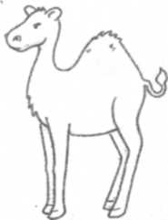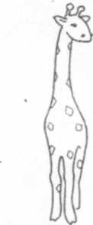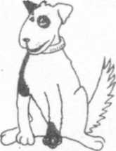

camel ________________ __________________

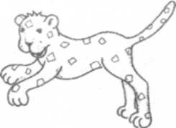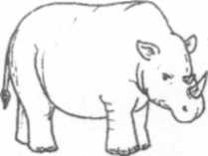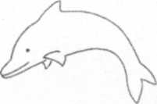

_____________ _______________ _________________

Circle the odd one out.

red hall blue pink green

- driver singer newspaper scientist reporter
- snail slow lucky young modern
- villa flat hospital tower statue
- Indian Egyptian English China Japanese
- dangerous adventure problem mistake accident

10 балів

3. Circle the correct word.
What's you/your name?
- Neil's father is a/an architect
- How old are he/they?
- Her/His name is Karini.
- Your/You're in Room 5.
- Breakfast is at/in seven o'clock.
- Look at the photo in/on page 10.
- Karini/Karini's is Helen's friend.
- It's Jack/Jack's rat.
- Are/Is there a cinema near here?
- They live with their/they parents.

10 балів
4. Write questions.

Snowy likes bread.
Does Snowy like bread?
1. There's a mirror in Jack's room.
___________________________________________________________________________
2. Cows usually sleep in the afternoon.
___________________________________________________________________________
3. Patrick and Helen can play chess.
___________________________________________________________________________
4. Jenny often swims after school.
___________________________________________________________________________
5. Frank has got a red jacket.
___________________________________________________________________________
6. You are sleeping in Room 502.
___________________________________________________________________________
7. The plane arrived two hours ago.
___________________________________________________________________________
8. It's going to rain in a minute!
___________________________________________________________________________
9. Tim ate pizza for lunch.
___________________________________________________________________________
10. Sarah lives near Manchester.
___________________________________________________________________________

20 балів

5. Write five sentences about Sophie's room.

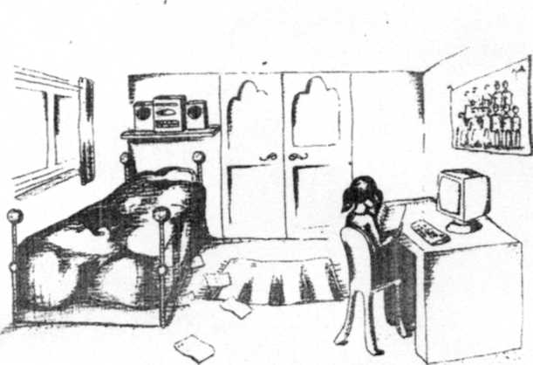

__________________________________________________________
__________________________________________________________
__________________________________________________________
__________________________________________________________
__________________________________________________________
__________________________________________________________

10 балів

